Overview
The Bureau of Transportation Statistics (BTS) collects, manages and shares transportation related statistical data. This data analysis focused on major commercial airlines on-time performance. The data analysis will include a population-based answer as well as a sample-based answer.
Question of Interest:
What time of the day and day of the week is best for avoiding flight delays?
There is 25 years of data available to use as the population, however, the population was redefined to include only the last 3 years (2011-2013). Airline operations have changed a great deal from 1992, including mergers, security behaviors after terrorist attacks in 2001 and 2006, and possible increased padding of flight schedules, thus using older data to identify the best day and time to avoid flight delays today is irrelevant.
Findings
Population-based Approach
Overall, each day of the week followed a similar trend, as shown in Figure 1. There is a peak average delay around 3:00 am, there is a low average delay around 5:00 am, and then the average delay increases until about 8:00 pm. Flights departing on Wednesday at 6:00 am had the shortest average delay time, about 5.5 minutes. Flights departing on Saturday at 3:00 am had the longest average delay time, about 21.5 minutes. Flights departing on Wednesday at 5:00 pm have the smallest proportion of delays at about 23% while flights on Thursday at 8:00 pm have the highest proportion of delays at about 51%.
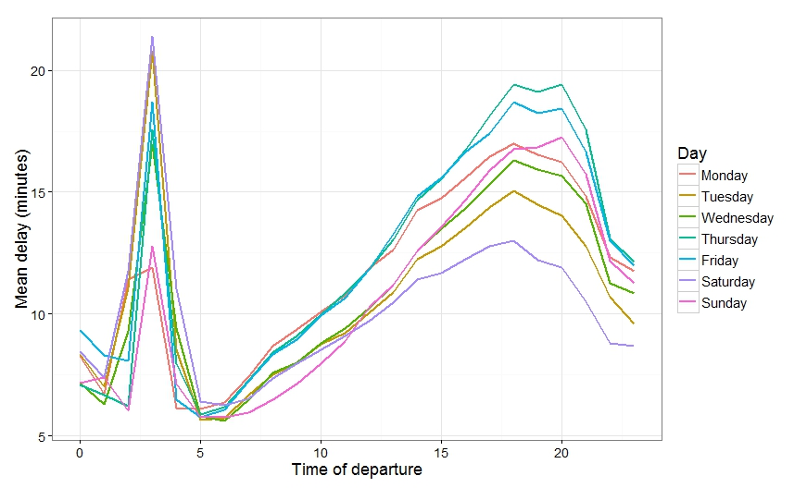
Figure 1: Average Delay Experienced by Time of Day and Day of Week for the Population
Obstacles and Solutions
- Time Index and Intervals
- Collecting Data/Size
- d
Sample-based Approach
We considered several sampling designs, and decided to stratify by day of week and hour of day. Our initial simple random sample gave small subsamples for late evening/early morning flights, and omitted some hours entirely on some days. By stratifiying we ensured we could estimate a value for all 168 (24 hours * 7 days) times. We sampled roughly 2000 flights in each stratum, or the whole population if that was smaller. Our sample data was highly consistent with the population data:
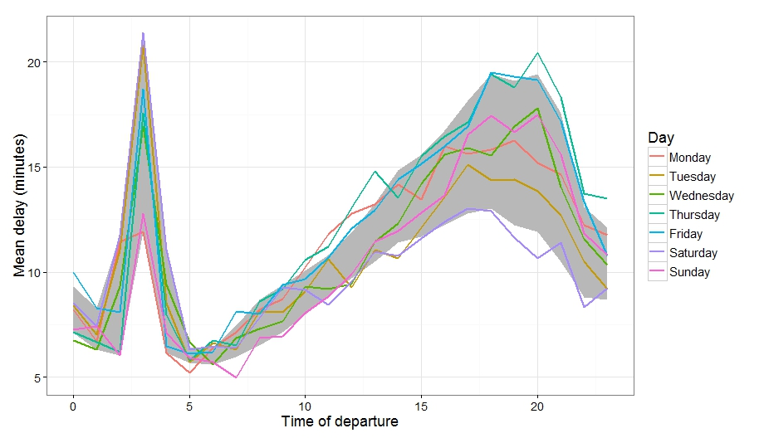
Figure 2: Average Delay Experienced by Time of Day and Day of Week for the Sample
The grey band in Figure 2 above represents the minimum and maximum average delay for each time of day from the population.
Obstacles and Solutions
Comparison
Future Work:
We have not yet investigated interactions: We see a general trend, but may be risking the “perils of aggregation”, because we're only addressing averages by time. We would like to examine whether these trends hold for all airports, all seasons, all airlines, and so on.

